CYPRUS ENVIROMENTALS AWARDS
FOR ORGANIZATIONS AND BUSINESSES
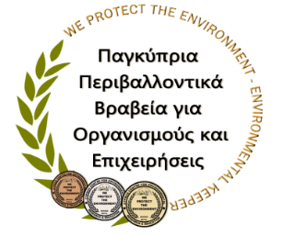

PARTICIPATION FORM

Organization / Business
Director Name:
Name of Responsible Person:
for the Cooperation Program with CYCERE

Please note √ the Award that you want your Organization / Business to join:
CYCERE Awards for the Environment in which we wish our Organization / business to join | “Bronze Environment Protector Award”
 | “Silver Environment Protector Award”
 | “Gold Environment Protector Award”

Contact information of the Organization / Business:

Address:
Other contact information | Director  Organization / Business | Responsible for the Award Program

Phone number

(preferably mobile):

Fax:

(Ε-mail)
Applications can be sent to CYCERE via fax (25 335682) or via email (kykpee@cytanet.com.cy). Upon receipt of your application, a member of the Scientific-Pedagogical team of CYCERE will contact you.

Signature of Director’s Organization / Business Date

………………............................................................................ ……............................

Notes: .....................................................................................................................................................................................
…. I accept the policy of CYCERE for Personal Data (GDPR).

Cyprus Center for Environmental Research and Education, 306th Agiou Andreou street, P.O.Box. 56091, 3304 Limassol Cyprus
Phone Number.: 25954954, 25864344, 99477309 / Fax: 25335682, 25371548 Website: www.kykpee.org Email: kykpee@cytanet.com.cy, a.chadjihambi@cytanet.com.cy

